How strong domestic clubs lead to national team success
By Narek Sahakyan, Michael W Nicholson and David Kritzberg

- Introduction: Spain is very good at football, as are Spaniards
Spain, the dominant national football team of the current era, hosts club teams that are also enjoying nearly unprecedented success. Our recent paper shows that this is no coincidence. Statistical techniques like two-stage least squares regression and a measure of quality defined by the performance of a nation’s club teams in international competitions demonstrate links between a country’s soccer performance at the aggregate professional club and at the national level.
The empirical literature on the determinants of international football performance generally incorporates macroeconomic measures and human development data that may correlate with long-term soccer success. In these “snapshot” studies, nations’ World Cup performance or FIFA points are usually regressed on wealth measures and population using a cross-section of countries. These variables are generally found to be good predictors of international soccer success, in which just population and income can explain upwards of fifty percent of variability in FIFA rankings.
We introduce domestic leagues and clubs – the place where the majority of players spend the majority of their playing careers, and where fans display their passion weekly – to the center of the discussion. A problem of endogeneity arises, because with the exception of Brazil, the same large, rich countries that traditionally host the strongest club leagues (Germany, Italy, Spain, England) also have realized extended success at the national level. For statistical purposes, our econometric specification among their relative determinants must accommodate the inherent endogeneity that the same players represent both club teams and national teams.

- Identification and Econometrics: Solving for the “Messi effects”
If club teams could employ only local players, we would expect an almost perfect correlation between a country’s aggregate club success and national success. In this autarky scenario, in which players performed only for their own nation’s domestic club teams, a country’s international club success would mirror its national success. However, free migration and trade of players complicates this relationship. As an example, consider the greatest player currently playing football: Lionel Messi, who lays for a club team in Spain but wears competes internationally for Argentina. While his contributions in international competition accrue directly to Argentina, there exist indirect “Messi effects” on the Spanish national team in which his weekly performance at the club level improves the quality of both his Barcelona teammates and his Madrid rivals (a selection of whom compete together under the Spanish flag.)
The usual trick in the presence of such endogeneity is to use “instrumental variables” that are directly correlated with one outcome and not the other. Often this method involves a system of lagged indicators, but we found a simple, intuitive solution in Chapter 7 of Kuper and Szymanksi’s Soccernomics (2009). They present an explanation for the historical dominance of provincial clubs in European soccer, and by extension global soccer. Football grew in the cities where industrialization occurred. Workers left their homes their lives in various parts of their country and migrated to the new industrial cities like Manchester, Barcelona, Turin, and Munich. Once there, they identified with the soccer clubs that were emerging there. With the exception of fascist regimes such as Spain, the capital cities of Europe found it harder to compete with the big clubs and their industrial worker fan bases. Populations in these cities tripled in a generation. So the big clubs are in Turin, not Rome; Munich, not Berlin; and Manchester, not London. Beyond Europe, the same pattern continued through the rest of the world. In other words, the industrial revolution encoded a stronger preference for soccer on industrial cities. Therefore, the countries with greater concentrations of urbanized population will tend to exhibit a stronger cultural preference for soccer.
We therefore consider the element of country’s urban population as an instrument for club success. National teams presumably draw on a fan base from the entire country. Professional clubs, however, depend on infrastructure, attendance and a strong local fan base for survival, which manifests itself in dense urban areas. Any relationship between urban population and national team success, as opposed to local club support, will be transmitted through the club success. If denser industrial cities lead to stronger club leagues or increase the efficiency of talented players, these players will be developed at the club level and gradually filter up through stronger clubs before arriving fully-formed on the international stage. Therefore, our identifying assumption is that a country’s percent of urban population is not correlated with football success at the national level through any channels other than its effect on the country’s club strength.

- Results
We constructed an index for national soccer endowment, “CLUB”, based on aggregate performance of the country’s club teams in international competitions. The index is created by summing up points and creating an annual ranking of all clubs by country, using only the points accumulated in international club competitions, according to the Oosterpark rankings. A critical feature of the CLUB variable is that club teams are defined by their geographical location. Chelsea is an English club, whether it starts 11 players from England, or none at all; whether it is owned by a foreign billionaire, or run by a council of borough elders. For the purposes of this study, the effects of any club team are defined exclusively by their impacts on the national team. Our identification strategy assumes that the instrument for CLUB, the urban population of a country, affects the success of the national team solely through its impact on domestic professional players.
Table 1 shows the results. Note that a higher CLUB ranking is associated with a lower value (being No. 1 is better than being No. 2) and thus a negative coefficient on the variable is associated with a positive impact on FIFA. We present regression results for a global sample (FIFA) and a European sub-sample (UEFA).
TABLE 1: Regression Results for FIFA and UEFA

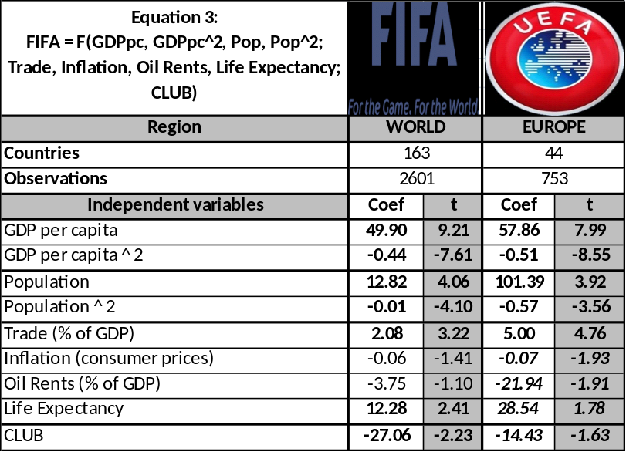
Notes: Bold and bold-italic indicate statistical significance at 5% and 10%, respectively.
Source: Authors’ calculations.

A very important result is that the endogenous CLUB is statistically significant at the 5% level for the whole FIFA sample, and at the 10% level for the UEFA subgroup. Its effect is about twice smaller for UEFA subgroup, compared to that of the whole sample, in line with Foer’s (2006) suggestion that strength of domestic leagues will have a weaker effect in Europe due to more intensive player trade.
Other major results of this paper provide further support for certain empirical rigidities in the relevant literature with the extension of the empirical method to include panel data and instrumental variables. With a few notable exceptions, like the United States and China, the larger, richer countries generally perform best at soccer. Countries with better living conditions, as proxied by life expectancy at birth, also generally perform better on the pitch. Access to international networks, as measured by the trade “openness”, has a positive impact in Europe. This is less the case for FIFA overall, mainly due to the exceptional performance of teams from South America. Higher dependence on oil rents is associated with lower soccer outcomes in Europe and North America, and conversely, with higher soccer success in South America.

- Concluding remarks: Will a European team triumph at Brazil 2014?
Club strength matters. U.S. Soccer benefits from the presence of both one of its better national team players, Landon Donovan, as well as the Frenchman Thierry Henry for New York Red Bulls, and -- until this year – the Englishman David Beckham, on the U.S. domestic club LA Galaxy because the stronger the domestic club league, MLS, the better should be the U.S. national team. Similarly, evidence shows that the English national team benefits from both the presence of the Dutchman Robin van Persie as well as the Englishman Wayne Rooney on Manchester United. Keep in mind that these results do not say anything about the value of players gaining experience in relatively tougher competition overseas, such as Clint Dempsey of the United States and Honda of Japan both playing in the EPL. We leave that question, following the work of Baur and Lehmann (2007), for another paper.
These current results highlight the internal logic that the best player in the world, Lionel Messi, plays for the best club in the world, FC Barcelona, which feeds a national team, Spain, that is enjoying unprecedented international success. They also, however, underscore the implications that none of the above are found in Brazil (or even Argentina). As the tournament hosts, the South Americans, and especially the Canarinho will enter the 2014 World Cup as the betting favorites. Should they fall short of the championship, our econometrics suggests the blame will be easy to find: in what Franklin Foer (2004) described as a corrupt, downtrodden domestic league.
REFERENCES
Baur, D. and Lehmann S. “Does the Mobility of Football Players Influence the Success of the National Team?”Institute for International Integration Studies, 2007, IIIS Discussion Paper No. 217.
Foer, F. “How Soccer Explains the World: An Unlikely Theory of Globalization.” New York,HarperCollins, 2004.
Foer, F. “How governments nurture soccer.”The New Republic, posted June 19, 2006.
Kuper, S. and Szymanksi, S.“Soccernomics: Why England Loses, Why Germany and Brazil Win, and Why the U.S., Japan, Australia, Turkey – and Even Iraq – Are Destined to Become Kings of the World’s Most Popular Sport.”Nation Books, 2009.
Sahakyan, N., Nicholson, M., and Kritzberg, D.“The Triumph of Passion: How strong domestic clubs lead to national soccer success”, 2012.

